Technical Note

|  |  |
| --- | --- |
| Product | 3D Printer 1800 |
| A/N # | TN-07-040 |
| Subject | UV lamps intensity power diagnose |
| No. Pages | 5 |
| Refer to T/N # |  |
| Written by | Ido Ami |
| Approved by |  |
| Edited by |  |
| Date | 4.11.2018 |

MASSIVit Website: http://massivit3d.com

Customer support: support@massivit.com

Table of Contents

Technical Note 1

1 Intro 3

1.1 Technical note description 3

1.2 Tools 3

1.3 Estimated time 3

1.4 Prerequisites 3

2 Installation procedure 4

3 5

Table of Figures

Figure 1: Modifying sensor position 3

Figure 2: Launching the troubleshooting SW 4

1. Intro
   1. Technical note description

This document describes in detail how to exam the UV lamps in a case of curing problems. basically, the process mapping a small rectangle area by moving the print head line by line and collect power spots which measured by a UV sensor. In the end of the process a matrix excel file would be export, this file should be exam by an authorized engineer.

* 1. Tools
* UV sensor
* Ventilate sensor
* Troubleshooting software
  1. Estimated time

Two hours.

* 1. Prerequisites

1. Connect the VU sensor to the computer.
2. To assure spaced area for movements locate the print head far away from the edges (at least 40cm from the x and Y limit switches)
3. Modify the high of the table so it would be 1mm high between the sensor and the nozzle tip edge.
4. Open the doors and center the sensor below the nuzzle.
5. Locate the ventilator in 30mm distance, assure the air flow across the sensor.

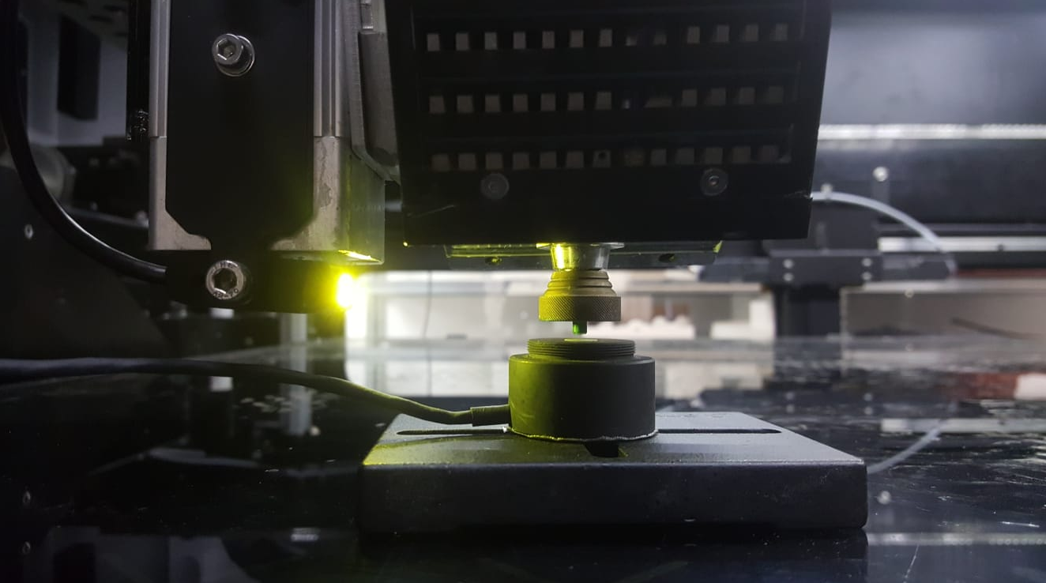

Figure 1 :modifying sensor position

1. Installation procedure
2. Assure the sensor driver already been install, if not, install it from the flash card under the folder rs232 -> PL-2303 Driver Installer.
3. Lunch the MassivitTroubleshootingTool software which located under E:\ArduinoUno4
4. On select text pick the “UVtest” tab.
5. Then run the test by clicking “start test “.

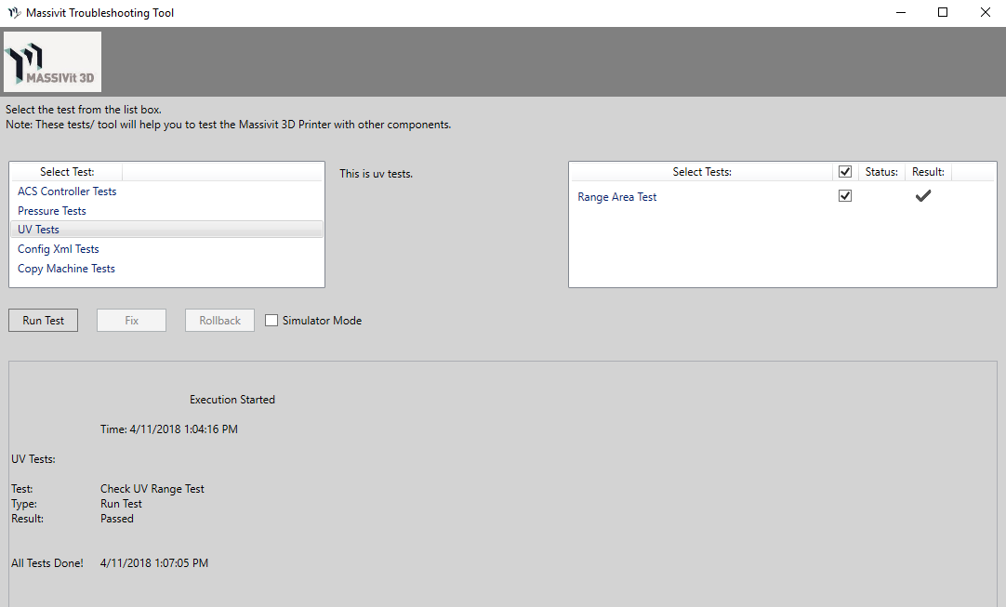

Figure 2 launching the troubleshooting SW

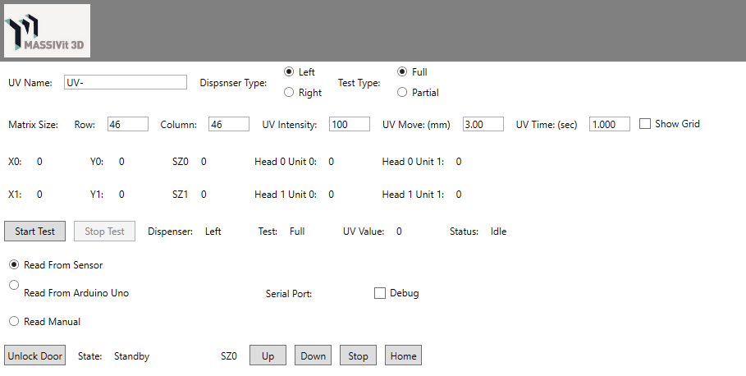

After one hour the data will be saved under E:\ArduinoUno4\TestsResult

Send the file to Massivit.